36.51: a) 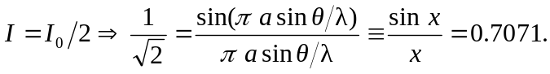 Solving for x through trial and error, and remembering to use radians throughout, one finds 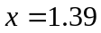 rad and 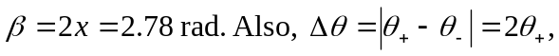 and
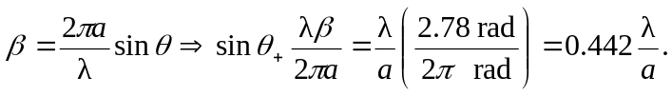
i)
ii)
iii)

b) For the first minimum, 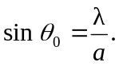
i) 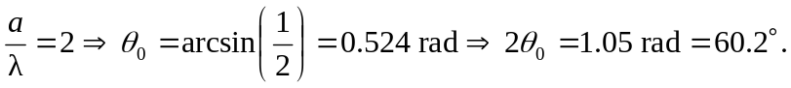
ii) 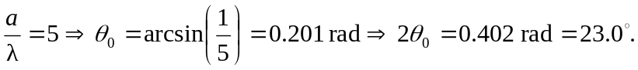
iii) 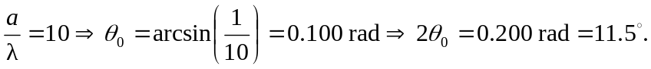
Both methods show the central width getting smaller as the slit width a is increased.

